**Classification Models for the Exchange Rate Directional Forecasts**

*Nichanan Logewitool, Shu-Chen Tsao, Xinru Gao*

**1. Introduction**

It is always a puzzle that which models will be the most appropriate tools to make a point forecast for an exchange rate, as it is usually highly noisy and thus unpredictable. Therefore, instead of the point forecast, we conduct a directional forecast of exchange rate directions which is more possible to generate a higher accuracy.

In this report, we attempt to forecast the direction of exchange rate one month ahead for 3 currency pairs including the U.S. Dollars-Japanese Yen, the U.S. Dollars-Euro and the U.S. Dollars-British Pounds. There are 6 predictors in each model which are the growth rate of unemployment rate, the growth rate of interest rate and inflation of each country. We collect monthly data from 2000 to 2019 and spilt it into 2 groups: 2000-2012 for training data and 2013-2019 for testing data and we will use 5 different model to fit our data including logistic regression model, ridge regression model, LASSO model, decision tree model and KNN model.

In terms of model selection, we will choose the best model based on the testing error rate and will perform a binomial test to ensure that our best model is outperforming the random walk model. In addition, we also build a portfolio generated from our best model to demonstrate its profitability in the real world.

**2. Data Description**

The predictors are the value and the growth rate of unemployment rate, the value and the growth rate of interest rate, and the growth rate of the price level (i.e., the inflation rate). Exchange rate pairs are defined by two currencies, such as the Japan/US exchange rate pair, a UK/US exchange rate pair and an EU/US exchange rate pair.

The data is downloaded from the Fred Database, the time frame is from Feb. 2000 to Jan. 2019 and the detailed description is shown below.

Daily Data (Convert to Month Data):

1. 3-Month London Interbank Offered Rate (LIBOR), based on British Pound.

Frequency: daily. Unit: percent, not seasonally adjusted.

1. 3-Month London Interbank Offered Rate (LIBOR), based on Japanese Yen.

Frequency: daily. Unit: percent, not seasonally adjusted.

1. 3-Month London Interbank Offered Rate (LIBOR), based on U.S. Dollar.

Frequency: daily. Unit: percent, not seasonally adjusted.

1. Japan / U.S. Foreign Exchange Rate.

Frequency: daily. Unit: Japanese Yen to One U.S. Dollar, Not Seasonally Adjusted.

1. U.S. /U.K. Foreign Exchange Rate.

Frequency: daily. Unit: U.S. Dollar to One U.K. Pound, Not Seasonally Adjusted.

Monthly Data:

1. Consumer Price Index: Total All Items for the United States.

Frequency: Monthly. Unit: Growth Rate Previous Period, Not Seasonally Adjusted.

1. Consumer Price Index: OECD Groups: All Items Non-Food for Japan.

Frequency: Monthly. Unit: Growth Rate Previous Period, Not Seasonally Adjusted.

1. Consumer Price Index: OECD Groups: All Items Non-Food and Non-Energy for the United Kingdom.

Frequency: Monthly. Unit: Growth Rate Previous Period, Not Seasonally Adjusted.

1. Consumer Price Index: Harmonized Prices: Total All Items Less Food, Energy, Tobacco, and Alcohol for the European Union.

Frequency: Monthly. Unit: Growth Rate Previous Period, Not Seasonally Adjusted.

1. Civilian Unemployment Rate of the United States.

Frequency: Monthly. Units: Percent, Not Seasonally Adjusted.

1. Unemployment Rate: Aged 15-64: All Persons for Japan.

Frequency: Monthly. Units: Percent, Not Seasonally Adjusted.

1. Registered Unemployment Rate for the United Kingdom.

Frequency: Monthly. Units: Percent, Not Seasonally Adjusted.

1. Unemployment Rate for the Europe Union.

Frequency: Monthly. Units: Percent, Not Seasonally Adjusted.

**3. Models**

We use 5 different models to fit our training data including logistic regression model, ridge regression model, LASSO model, decision tree model and KNN model. We will evaluate each model performance based on its testing error rate and choose the one with the lowest testing error rate.

**3.1. Logistic Regression Model**

Logistic regression model is considered to be an appropriate model when the dependent variable is binary. As we aim to classify the future direction of the exchange rate, the dependent variable will be 1 if it is predicted that it will go up. On the other hand, it will be 0 if it is predicted that it will go down next month.

The plot of predicted probability for the US-Japan, the US-UK and the US-EU exchange rate are shown below. We can see from figure 1 that for the US-Japan, most predicted probabilities are less than 0.5; thus, it is highly likely that the US-Japan exchange rate will go down next month. However, for the US-UK and the US-EU in figure 2 and 3, the predicted probability is closed to the normal distribution even if there is a little more probability that the exchange rate will go down rather than go up.

**Figure 1: The predicted probability of the US-Japan exchange rate**

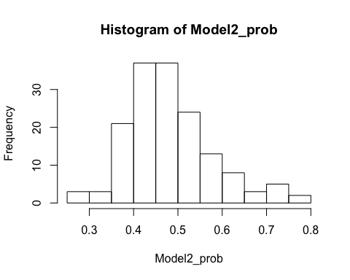

**Figure 2: The predicted probability of the US-UK exchange rate**

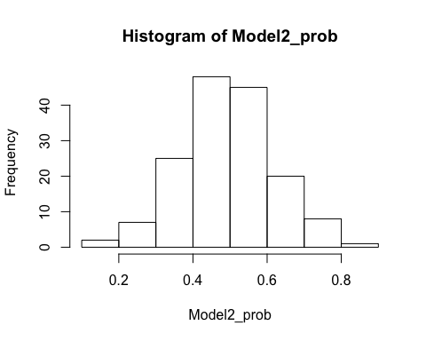

**Figure 3: The predicted probability of the US-EU exchange rate**

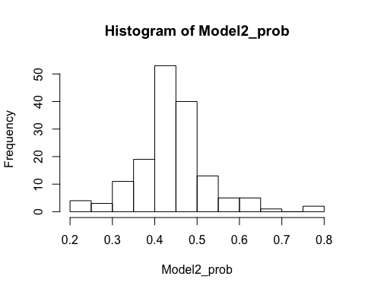

After getting the prediction for each currency pair, we compute a confusion matrix to evaluate the model performance as followed.

|  |  |  |
| --- | --- | --- |
| Confusion matrix of the US-Japan exchange rate prediction | | |
|  | Predicted Direction = Down | Predicted Direction = Up |
| True Value = Down | 24 | 9 |
| True Value = Up | 28 | 11 |

|  |  |  |
| --- | --- | --- |
| Confusion matrix of the US-UK exchange rate prediction | | |
|  | Predicted Direction = Down | Predicted Direction = Up |
| True Value = Down | 27 | 12 |
| True Value = Up | 18 | 15 |

|  |  |  |
| --- | --- | --- |
| Confusion matrix of the US-EU exchange rate prediction | | |
|  | Predicted Direction = Down | Predicted Direction = Up |
| True Value = Down | 29 | 6 |
| True Value = Up | 27 | 10 |

In addition to the confusion matrix, we compute the testing error rate to measure the performance. The lower the testing error rates are, the more accurate our model is. The table below shows a summary of each exchange rate pair’s testing error rate. We can see that on average, the testing error rate of the logistic regression model is 46.3%

|  |  |
| --- | --- |
| Results: Logistic Regression | Testing Error Rate |
| JP / US Exchange Pair | 51.39% |
| UK / US Exchange Pair | 41.67% |
| EU / US Exchange Pair | 45.83% |

**3.2 Ridge Regression Model**

We fit the ridge regression model by using cross validation to choose the best lambda which minimize the binomial deviance in cross-validation. Then we plot the coefficient of each model to see the importance of each variables. The faster the coefficient of variable shrinks to zero, the less important the variable is. The results are concluded in the table below.

|  |  |  |
| --- | --- | --- |
|  | Important Variables | Less Important Variables |
| JP / US Exchange Pair | The Growth Rate of Unemployment Rate in All Four Countries | Interest Rate in UK  Interest Rate in EU |
| UK / US Exchange Pair | The Growth Rate of Unemployment Rate in UK  The Growth Rate of Interest Rate in UK and US | Inflation in EU |
| EU / US Exchange Pair | The Growth Rate of Unemployment Rate in EU  The Growth Rate of Interest Rate in US and UK | Unemployment Rate in US |

As the table showing above, we find that the growth rate of unemployment rate in all four countries has important impact on JP/US exchange pair while interest rate in UK and EU has less important effect; the growth rate of unemployment rate in UK and the growth rate of interest rate in UK and US has important effect on UK/US exchange pair, while inflation in EU has less important effect; the growth rate of unemployment rate in EU and the growth rate of interest rate in US and UK has important impact on EU/US exchange pair, while unemployment rate in US has less effect.

The important variables are the vital variables to improve the accuracy for each exchange pair prediction. On the contrary, the variables that have less important effect on the each exchange pair, we may can eliminate them from our regression models.

After getting the prediction of ridge regression, we compute the confusion matrix to evaluate the model.

|  |  |  |
| --- | --- | --- |
| Confusion matrix of the US-JP exchange rate prediction | | |
|  | Predicted Direction = Down | Predicted Direction = Up |
| True Direction = Down | 28 | 5 |
| True Direction = Up | 33 | 6 |

|  |  |  |
| --- | --- | --- |
| Confusion matrix of the US-UK exchange rate prediction | | |
|  | Predicted Direction = Down | Predicted Direction = Up |
| True Value = Down | 33 | 6 |
| True Value = Up | 29 | 4 |

|  |  |  |
| --- | --- | --- |
| Confusion matrix of the US-EU exchange rate prediction | | |
|  | Predicted Direction = Down | Predicted Direction = Up |
| True Value = Down | 35 | 0 |
| True Value = Up | 37 | 0 |

In addition to the confusion matrix, we compute the testing error rate to measure the performance. The lower the testing error rates are, the more accurate our model is. The table below shows a summary of each exchange rate pair’s testing error rate. We can see that on average, the testing error rate of the ridge regression model is 50.46%

|  |  |
| --- | --- |
| Results: Ridge Regression | Testing Error Rate |
| JP / US Exchange Pair | 52.78% |
| UK / US Exchange Pair | 47.22% |
| EU / US Exchange Pair | 51.39% |

**3.3 LASSO Model**

LASSO model is a better version of ridge regression model. It applies a different penalty which can prove the model mathematically by setting some coefficient end up being exactly zero. With LASSO, we can produce a model that has high predictive power and it is simple to interpret.

We use cross validation to find the best lambda and plot the coefficient as same as the ridge model. The results are concluded in the table below.

|  |  |  |
| --- | --- | --- |
|  | Important Variables | Less Important Variables |
| JP / US Exchange Pair | — | ALL |
| UK / US Exchange Pair | The Growth Rate of Unemployment Rate in UK | The Others |
| EU / US Exchange Pair | The Growth Rate of Interest Rate in US and UK | The Others |

As the table showing above, we find that the LASSO model shrink all the coefficient into zero in the JP/US exchange pair, which means that the variables we choose to predict the JP/US exchange pair does not have enough important impact on this exchange pair; the growth rate of unemployment rate in UK have important effect on UK/US exchange pair, while the other variables does not; the growth rate of interest rate in US and UK has important effect on EU/US exchange pair, while the other variables does not.

After getting the prediction of LASSO model, we compute the confusion matrix to evaluate the model.

|  |  |  |
| --- | --- | --- |
| Confusion matrix of the US-JP exchange rate prediction | | |
|  | Predicted Direction = Down | Predicted Direction = Up |
| True Direction = Down | 33 | 0 |
| True Direction = Up | 39 | 0 |

|  |  |  |
| --- | --- | --- |
| Confusion matrix of the US-UK exchange rate prediction | | |
|  | Predicted Direction = Down | Predicted Direction = Up |
| True Value = Down | 32 | 7 |
| True Value = Up | 27 | 6 |

|  |  |  |
| --- | --- | --- |
| Confusion matrix of the US-EU exchange rate prediction | | |
|  | Predicted Direction = Down | Predicted Direction = Up |
| True Value = Down | 35 | 0 |
| True Value = Up | 36 | 1 |

In addition to the confusion matrix, we compute the testing error rate to measure the performance. The lower the testing error rates are, the more accurate our model is. The table below shows a summary of each exchange rate pair’s testing error rate. We can see that on average, the testing error rate of the LASSO model is 50%

|  |  |
| --- | --- |
| Results: Ridge Regression | Testing Error Rate |
| JP / US Exchange Pair | 54.17% |
| UK / US Exchange Pair | 47.22% |
| EU / US Exchange Pair | 48.61% |

**3.4 Decision Tree Model**

In this part, we will build one basic tree model and one random forest tree model and choose the one with lower error rate as our representative of the decision tree model.

**3.4.1 Basic Tree Model**

Below is one of the tree-graph in the basic tree models. For instance, to forecast the exchange rate of US/JP, we can see that the splitting starts from if the unemployment growth rate of Japan < 0.076, and so on. There will be 11 partitions in the model when the splitting ends.

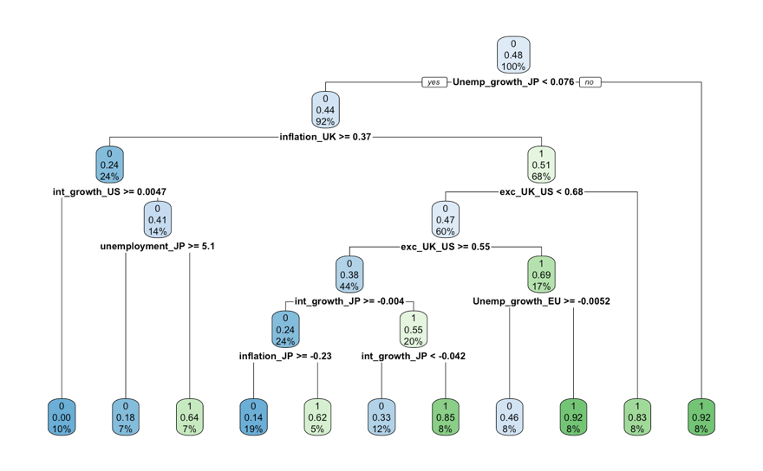

The testing error rate is provided as below.

|  |  |
| --- | --- |
| Results: Basic Tree | Testing Error Rate |
| JP / US Exchange Pair | 47.22% |
| UK / US Exchange Pair | 47.22% |
| EU / US Exchange Pair | 61.11% |

On average, the testing error rate of the basic tree model is 51.85%. It is over 50%, which shows the basic tree model is not suitable of the task. Instead, we will try the random forest model.

**3.4.2 Random Forest Model**

A random forest model could provide an improvement to the decision tree models as the random forest de-correlates the trees by randomly sampling some predictors instead of all predictors for splitting. Actually, the random forest model does outperform the basic tree models as shown in the following analysis.

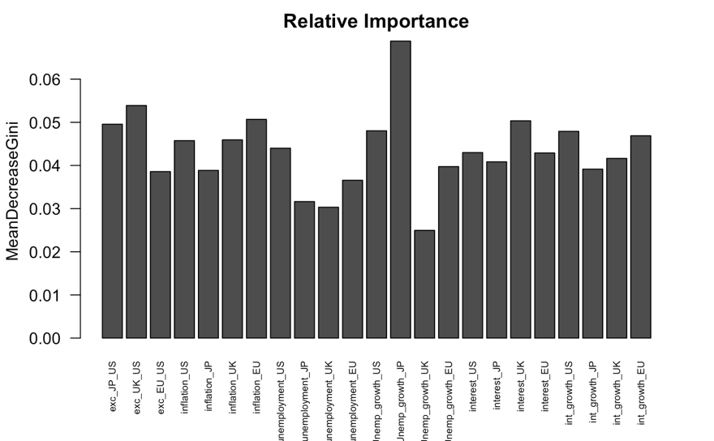

Above is the relative importance plot of the random forest model applied on the JP/US exchange rate pair. We can see that the growth rate of the unemployment in Japan has the largest relative importance, whereas the growth rate of the unemployment in the UK has the lowest.

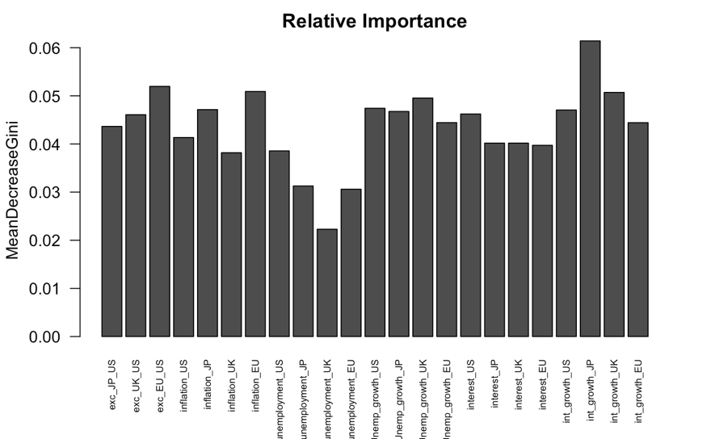

Above is the relative importance plot of the random forest model applied on the UK/US exchange rate pair. We can see that the growth rate of the growth of the interest rate in Japan has the largest relative importance, whereas the unemployment in the UK has the lowest.

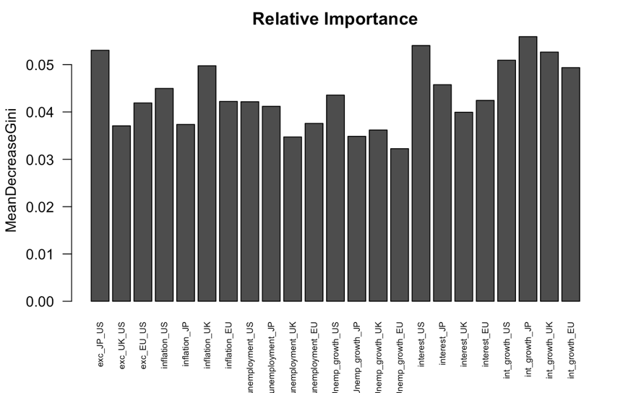

Above is the relative importance plot of the random forest model applied on the EU/US exchange rate pair. We can see that the growth rate of the growth of the interest rate in Japan has the largest relative importance, whereas the growth rate of unemployment in EU has the lowest.

We can further compute a confusion matrix to evaluate the model performance as followed.

|  |  |  |
| --- | --- | --- |
| Confusion matrix of the US-Japan exchange rate prediction | | |
|  | Predicted Direction = Down | Predicted Direction = Up |
| True Direction = Down | 7 | 26 |
| True Direction = Up | 3 | 36 |

|  |  |  |
| --- | --- | --- |
| Confusion matrix of the US-UK exchange rate prediction | | |
|  | Predicted Direction = Down | Predicted Direction = Up |
| True Value = Down | 16 | 23 |
| True Value = Up | 18 | 15 |

|  |  |  |
| --- | --- | --- |
| Confusion matrix of the US-EU exchange rate prediction | | |
|  | Predicted Direction = Down | Predicted Direction = Up |
| True Value = Down | 30 | 5 |
| True Value = Up | 25 | 12 |

In addition to the confusion matrix, we compute the testing error rate to measure the performance. The lower the testing error rates are, the more accurate our model is. The table below shows a summary of each exchange rate pair’s testing error rate. We can see that on average, the testing error rate of the random forest model is 46.3%.

|  |  |
| --- | --- |
| Results: Random Forest | Testing Error Rate |
| JP / US Exchange Pair | 40.28% |
| UK / US Exchange Pair | 56.95% |
| EU / US Exchange Pair | 41.67% |

**3.5 KNN Model**

The KNN model is to find the nearest neighbors for a new data point in the training dataset. After getting the prediction for each currency pair, we compute a confusion matrix to evaluate the model performance as followed.

|  |  |  |
| --- | --- | --- |
| Confusion matrix of the US-Japan exchange rate prediction | | |
|  | Predicted Direction = Down | Predicted Direction = Up |
| True Direction = Down | 21 | 12 |
| True Direction = Up | 17 | 22 |

|  |  |  |
| --- | --- | --- |
| Confusion matrix of the US-UK exchange rate prediction | | |
|  | Predicted Direction = Down | Predicted Direction = Up |
| True Value = Down | 22 | 17 |
| True Value = Up | 16 | 17 |

|  |  |  |
| --- | --- | --- |
| Confusion matrix of the US-EU exchange rate prediction | | |
|  | Predicted Direction = Down | Predicted Direction = Up |
| True Value = Down | 23 | 12 |
| True Value = Up | 23 | 14 |

In addition to the confusion matrix, we compute the testing error rate to measure the performance. The lower the testing error rates are, the more accurate our model is. The table below shows a summary of each exchange rate pair’s testing error rate. We can see that on average, the testing error rate of the KNN model is 44.9%.

|  |  |
| --- | --- |
| Results: KNN Model | Testing Error Rate |
| JP / US Exchange Pair | 40.28% |
| UK / US Exchange Pair | 45.83% |
| EU / US Exchange Pair | 48.61% |

Because the KNN has the lowest average testing error rate among the models, we will pick the KNN model as our best model.

**4. Statistical Test and Performance Measure**

After selecting the KNN as our best model basing on the lowest average testing error rate, we would like to demonstrate whether the model significantly outperforms the random walk. Therefore, we will perform a one-sided exact binomial test.

$$H_{0}: Testing Error Rate = 50\%$$

$$H_{1}: Testing Error Rate< 50\%$$

The p-value of performing the one-sided exact binomial test on the recursive KNN model is around 0.07, which shows that it performs better than merely a fifty-fifty coin-flipping as the p-value is close to the threshold of 0.05.

To show the performance, aside from the binomial test, we would also build a portfolio generated from the recursive KNN model to demonstrate its profitability in the real world. The strategy is that when we predict Japanese yen to appreciate against US dollar for the next month, we will buy one unit of Japanese yen at the present and sell it in the next month. On the contrary, if we predict Japanese yen to depreciate against US dollar for the next month, we will buy one unit of US dollar at the present and sell it in the next month. The rule is also identical for the UK/US exchange rate pair and the EU/US exchange rate pair. Below is the holding period return (monthly return in our case) of implementing the model. The average annualized return will be approximately 2.49%.



**5. Conclusion and Future Work**

In the report, we applied five machine learning models to predict the direction of the exchange rates. The KNN model has the lowest testing error rate, and the p-value to reject the one-sided binomial test is 0.07 despite of the nature of highly noisy and unpredictability of the exchange rates. The profit could be 2.49% per year if we implement the model on the real-world data. Our future work could be combining the machine learning models that we used in the report with other time series models, such as ARIMA, VAR or filtering tools, as there might show some auto-correlation in the exchange rates, which could also be useful to improve the accuracy of the forecasts.

**6. Reference**

The data analyzed in the report is retrieved from <https://fred.stlouisfed.org/> managed by the Federal Reserve Bank of St. Louis.